EzBrzy Homework Planner Mobile Application: V.1.0

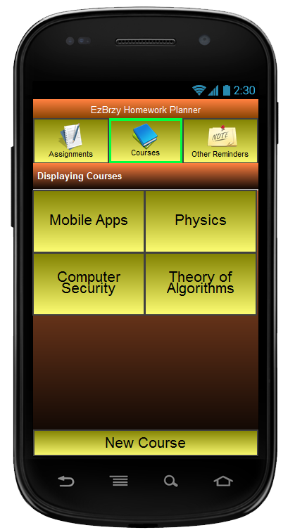

Plan submitted by: Cora Charneskey & Eric Wilcox

Application Objective:
The EzBrzy Homework Planner will assist students to easily and quickly record homework information for a class by allowing the assignment reminder to be entered within less than 5 seconds by only pushing 3 buttons after opening the application. Users can optionally go back to record details about the assignment if needed. When the application is loaded the main screen will be a simple list of assignments and details of each assignment can be accessed with one click. The assignment listview will be the applications most convenient feature, allowing the student to view the majority of their assignments in one glance.

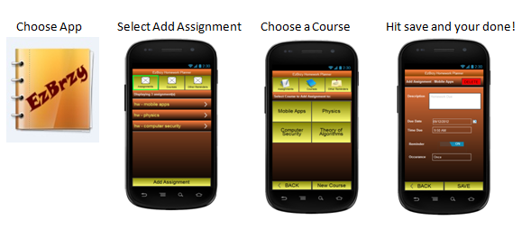

The default description for any homework entry will be “class name” + “homework”, with the “class name” being dynamic. This feature will make it easy to choose in three easy steps, “Add Assignment”, “Select Course”, and then “Save”. Then when the student has time, details can be added into the application regarding the assignment. From experience, a simple reminder of what classes you have homework in will do since many instructors host a website with assignments listed that you can reference for complete details. This is just one of the ways that the application is customizing itself to the true needs of a student.

If the student chooses to set up courses beforehand, which is recommended, then the default time due and date due can be set. This will make it again simpler when entering assignments. If defaults are not set, then the factory defaults will be set to alarm the student that same day at 5:00pm that the assignment is due. The reminder itself will default to “ON”.

An “Other Reminders” tab will be provided to allow the student to keep personal or work tasks separate from homework assignments to keep things organized. When chosen, just like the “Assignments Tab”, a list of tasks will be displayed and each can be accessed for details.

The EzBrzy Homework Planner is different from other homework planner applications because it is very simple to use and does not include any unnecessary features that clutter the screen space.

Application Operations:
- Add course/course location
- Edit or delete course information
- Set default time and date for assignment due for each course
- Add/delete assignments for a particular course
- View assignments in a list view and access details by selecting assignment
- Add/delete other reminders
- View other reminders in a list view and access details by selecting the reminder

User stories:
Bob’s class runs over a little and homework is assigned at the last minute. In a rush to get to his next class he’s halfway to the door and realizes he didn’t write down the homework assignment. With all his books on his back and students trying to get out around him, he opens the application and in 3 taps adds a reminder that there is homework in the class so he can later get the details and won’t forget about the homework, or be late to his next class by pulling books out again to copy details down.

Bella is a freshman in high school and has trouble remembering her homework. She is not allowed to use her phone in class and has gotten in trouble many times for it. She knows she’ll forget the homework again and not wanting to get in any more trouble she downloads the app, enters her classes the night before under “courses”. She’s ready to use the app for homework, but remembers on her way to bed that she has a dentist appointment in 2 days she can’t forget. She opens the app, quickly adding a miscellaneous reminder under “Other” and it defaults to the next day. When the reminder goes off, she sits down to type up the details and resets the reminder.

Danny is starting at a new semester and wants to get organized beforehand. After he obtains the homework app on his phone, he enters each of his courses, the times they take place, what room he needs to go to, his instructors name, and presets a reminder time specifying when he should be alerted if an assignment is entered for the class. He adds some additional details about the homework he expects to come up, and is ready to tackle the next semester knowing he won’t easily forget any assignments.

Requirements:
- JavaScript, jQuery, and jQueryMobile
- Android 2.2 Device (minimum)
- Install and implement the Mobiscroll plugin (for date and time picker)
- Implement an organized file system between classes, assignment, and notes
- Continue developing the remaining pages
- Adjust theme through theme-roller
- Linking the native alarm API to application
- Implement alert dialog when deleting items
- Review and adjust device permission

Progress report:
The minimum viable product is complete. This product includes the three main screens accessed from the top navigation bar (Assignments, Courses, Other Reminders). A theme has been loaded, custom icons have been added to the navigation bar, and the class to show that an element is selected has been added so the user knows which page they are on. The screen orientation has been set to handle both portrait and landscape views. A function to allow the number of assignments, courses and other reminders currently being displayed has been started. Note that test data has been left on the main page in order to demonstrate the fixed header and footer bars with the center scrolling. The file API has been implemented for the “Other Reminders” section that currently logs a date and time when you save a new note. Notes are displayed when you open the tab and refreshed upon deleting or saving new notes.

Upon approval to continue, the following tasks will need to be completed:
- Code for the remaining screens:
  - Events added to all the buttons
  - jQuery selectors and appends to all the correct screens
  - Implement mobiscroll and pop-up dialog plugins
- Styling/theme will need to be finalized.
- A file system to store information supplied by the user will need to be designed and incorporated into the application.
- The Android alarm system API will be referenced in order to sound alarms for the application.
- Set app to default to “Assignments” tab when loaded.

Some issues that we have experienced or anticipate are:
- Debugging on different mobile devices aside from the simulator has had its downfalls. Sometimes the driver for the ADB (Android Debugging Bridge) will not be detected and then Eclipse fails to detect the device. Fixing environment problems such as this has been challenging.
- Implementing the file system
- Working with jQueryMobile to display the information correctly on the device
  - Need to fix navigation bar ellipse truncation issue. A <span> was implemented but did not work. Wrapping the text in a <div> or <p> and overriding the CSS works but generates html errors. This site suggest a solution that does work if the text is wrapped in a <p> tag, but then the error still exists on the html side. http://stackoverflow.com/questions/5799980/how-to-keep-this-p-from-getting-clipped-when-it-exceeds-the-width-of-the-page
- Listview items are not displaying correctly. .listview(‘refresh’) has not solved display problem yet.

Time Estimate to Finish Project:
Estimated time to finish application: 80 hours

Full Project Mock-up:
ericswilcox.com/mobile_apps/ezbrzy_mockup.html

